# Name: Nguyễn Quốc Thắng StudentID: s3806617

## Activity 1 - Human Computer Interface (HCI) Analysis

## 

### Crown Casino: [[http://www.crownmelbourne.com.au](http://www.crownmelbourne.com.au/)]:

Here is a snapshot of Crown Casino's home page:

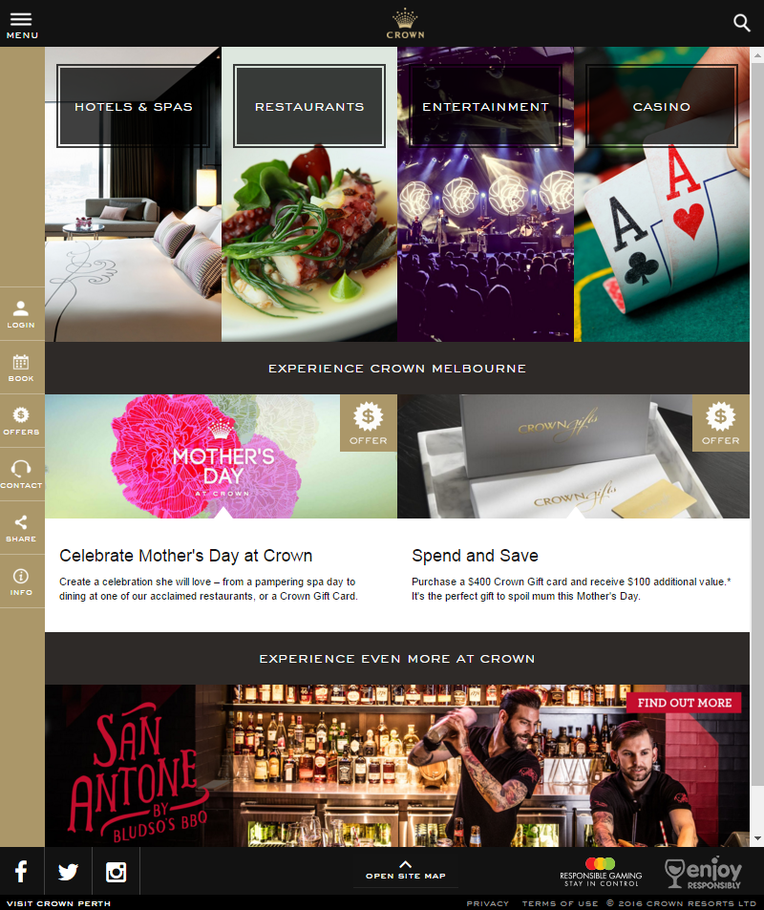

Discuss the following questions:

* What are the four business areas they are promoting on the home page? What types of audiences are they appealing to?

1. They are prompting Hotels&Spa , restaurants, entertainment and casino
2. They are targeting audience that are looking for relaxations and vacations

* Is the content on this home page (landing page) general in nature? Does it capture all audiences without alienating anyone?
  + I think that the design language on this page is really general and can capture all audiences attention
* Are there any issues with contrast that will impact the visually impaired? Have any compromises been made in the name of stylish design? Test your color choices here: <https://contrast-ratio.com/>
  + I think that there are no issues with the contrast that will impact the visually impaired

* Is the interface at all confusing? Does this website pose any problems for those with mobility or intellectual disabilities?
  + It may be a little bit confusing and complicated for someone with intellectual disabilities.

Crown Casino charges rent from their commercial tenants. The success of Crown's business depends on the success of the tenants' businesses and so it makes sense for Crown to promote their tenants' businesses within their website. Below is a screenshot from the restaurant's and food market businesses category:

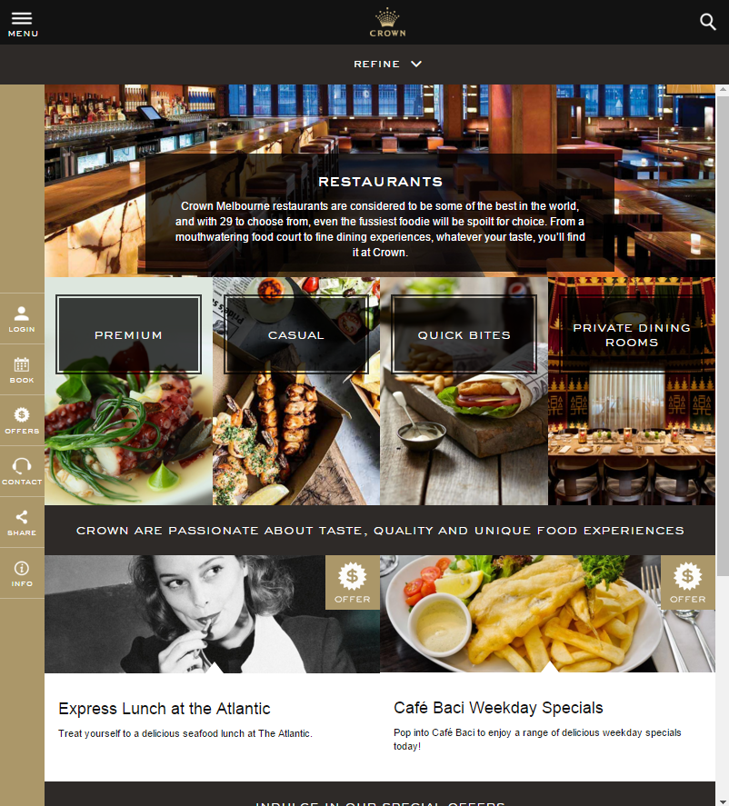

The content on this landing page is more specific: relating to places to eat, but it is still a landing page for 4 general types of audience. Name the 4 types of audience and is there any significance with the placement of each group of restaurants on the page?

* The 4 types of audience are:

1. Premium: People that will pay a lot for high-end foods and drink
2. Casual: People that will pay a reasonable price for foods and drink
3. Quick bites: People that is looking for a quick meal (fast-food, sandwich ,..)
4. Private dining room: People who are looking a more premium and personal environment while eating.

* The Casual and Quick bites are being displayed at the middle of the page because they are most likely the most chosen options out of the 4 and probably the main income of the restaurant. The Premium and Private dining room are special services with a higher price so they were displayed at either side

Think about what might attract each group and what would "scare" them away? In particular, how does it appeal to those looking for a lavish place to eat (eg Heston Blumenthal's restaurant?) without intimidating those who are on a budget and just want to visit KFC or McDonalds?

* To appeal to who are looking for a lavish place to eat without intimidating who are on a budget. The restaurant has put 2 of the cheap options in the middle of the website while the other remaining 2 premium options were displayed either side